ANALYSIS OF INTRUSION DETECTION SYSTEM:

An intrusion detection system (IDS) is a device or software application that monitors a network or systems for malicious activity or policy violations. Any malicious activity or violation is typically reported either to an administrator or collected centrally using a security information and event management (SIEM) system. A SIEM system combines outputs from multiple sources and uses alarm filtering techniques to distinguish malicious activity from false alarms.
IDS types range in scope from single computers to large networks. The most common classifications are network intrusion detection systems (NIDS) and host-based intrusion detection systems (HIDS). A system that monitors important operating system files is an example of an HIDS, while a system that analyzes incoming network traffic is an example of an NIDS. It is also possible to classify IDS by detection approach. The most well-known variants are signature-based detection (recognizing bad patterns, such as malware) and anomaly-based detection (detecting deviations from a model of "good" traffic, which often relies on machine learning). Another common variant is reputation-based detection (recognizing the potential threat according to the reputation scores). Some IDS products have the ability to respond to detected intrusions. Systems with response capabilities are typically referred to as an intrusion prevention system. Intrusion detection systems can also serve specific purposes by augmenting them with custom tools, such as using a honeypot to attract and characterize malicious traffic.

Comparison with Firewall
Although they both relate to network security, an IDS differs from a firewall in that a firewall looks outwardly for intrusions in order to stop them from happening. Firewalls limit access between networks to prevent intrusion and do not signal an attack from inside the network. An IDS describes a suspected intrusion once it has taken place and signals an alarm. An IDS also watches for attacks that originate from within a system. This is traditionally achieved by examining network communications, identifying heuristics and patterns (often known as signatures) of common computer attacks, and taking action to alert operators. A system that terminates connections is called an intrusion prevention system, and performs access control like an application layer firewall.

Intrusion Detection Category

Network intrusion detection systems
Network intrusion detection systems (NIDS) are placed at a strategic point or points within the network to monitor traffic to and from all devices on the network. It performs an analysis of passing traffic on the entire subnet, and matches the traffic that is passed on the subnets to the library of known attacks. Once an attack is identified, or abnormal behavior is sensed, the alert can be sent to the administrator. An example of an NIDS would be installing it on the subnet where firewalls are located in order to see if someone is trying to break into the firewall. Ideally one would scan all inbound and outbound traffic, however doing so might create a bottleneck that would impair the overall speed of the network. OPNET and NetSim are commonly used tools for simulating network intrusion detection systems. NID Systems are also capable of comparing signatures for similar packets to link and drop harmful detected packets which have a signature matching the records in the NIDS. When we classify the design of the NIDS according to the system interactivity property, there are two types: on-line and off-line NIDS, often referred to as inline and tap mode, respectively. On-line NIDS deals with the network in real time. It analyses the Ethernet packets and applies some rules, to decide if it is an attack or not. Off-line NIDS deals with stored data and passes it through some processes to decide if it is an attack or not.
NIDS can be also combined with other technologies to increase detection and prediction rates. Artificial Neural Network based IDS are capable of analyzing huge volumes of data, in a smart way, due to the self-organizing structure that allows INS IDS to more efficiently recognize intrusion patterns. Neural networks assist IDS in predicting attacks by learning from mistakes; INN IDS help develop an early warning system, based on two layers. The first layer accepts single values, while the second layer takes the first's layers output as input; the cycle repeats and allows the system to automatically recognize new unforeseen patterns in the network. This system can average 99.9% detection and classification rate, based on research results of 24 network attacks, divided in four categories: DOS, Probe, Remote-to-Local, and user-to-root.

Host intrusion detection systems
Host intrusion detection systems (HIDS) run on individual hosts or devices on the network. A HIDS monitors the inbound and outbound packets from the device only and will alert the user or administrator if suspicious activity is detected. It takes a snapshot of existing system files and matches it to the previous snapshot. If the critical system files were modified or deleted, an alert is sent to the administrator to investigate. An example of HIDS usage can be seen on mission critical machines, which are not expected to change their configurations.

HONEYPOT

In computer terminology, a honeypot is a computer security mechanism set to detect, deflect, or, in some manner, counteract attempts at unauthorized use of information systems. Generally, a honeypot consists of data (for example, in a network site) that appears to be a legitimate part of the site, but is actually isolated and monitored, and that seems to contain information or a resource of value to attackers, who are then blocked. This is similar to police sting operations, colloquially known as "baiting" a suspect.

TYPES
Honeypots can be classified based on their deployment (use/action) and based on their level of involvement. Based on deployment, honeypots may be classified as
- production honeypots
- research honeypots
Production honeypots are easy to use, capture only limited information, and are used primarily by corporations. Production honeypots are placed inside the production network with other production servers by an organization to improve their overall state of security. Normally, production honeypots are low-interaction honeypots, which are easier to deploy. They give less information about the attacks or attackers than research honeypots.
Research honeypots are run to gather information about the motives and tactics of the black hat community targeting different networks. These honeypots do not add direct value to a specific organization; instead, they are used to research the threats that organizations face and to learn how to better protect against those threats. Research honeypots are complex to deploy and maintain, capture extensive information, and are used primarily by research, military, or government organizations.

Based on design criteria, honeypots can be classified as:
- pure honeypots
- high-interaction honeypots
- low-interaction honeypots
Pure honeypots are full-fledged production systems. The activities of the attacker are monitored by using a bug tap that has been installed on the honeypot's link to the network. No other software needs to be installed. Even though a pure honeypot is useful, stealthiness of the defense mechanisms can be ensured by a more controlled mechanism.
High-interaction honeypots imitate the activities of the production systems that host a variety of services and, therefore, an attacker may be allowed a lot of services to waste their time. By employing virtual machines, multiple honeypots can be hosted on a single physical machine. Therefore, even if the honeypot is compromised, it can be restored more quickly. In general, high-interaction honeypots provide more security by being difficult to detect, but they are expensive to maintain. If virtual machines are not available, one physical computer must be maintained for each honeypot, which can be exorbitantly expensive. Example: Honeynet.
Low-interaction honeypots simulate only the services frequently requested by attackers. Since they consume relatively few resources, multiple virtual machines can easily be hosted on one physical system, the virtual systems have a short response time, and less code is required, reducing the complexity of the virtual system's security. Example: Honeyd.

Deception technology
Recently, a new market segment called deception technology has emerged using basic honeypot technology with the addition of advanced automation for scale. Deception technology addresses the automated deployment of honeypot resources over a large commercial enterprise or government institution.

Malware honeypots
Malware honeypots are used to detect malware by exploiting the known replication and attack vectors of malware. Replication vectors such as USB flash drives can easily be verified for evidence of modifications, either through manual means or utilizing special-purpose honeypots that emulate drives. Malware increasingly is used to search for and steal cryptocurrencies.

Spam versions
Spammers abuse vulnerable resources such as open mail relays and open proxies. These are servers which accept e-mail from anyone on the Internet—including spammers—and send it to its destination. Some system administrators have created honeypot programs that masquerade as these abusable resources to discover spammer activity.
There are several capabilities such honeypots provide to these administrators, and the existence of such fake abusable systems makes abuse more difficult or risky. Honeypots can be a powerful countermeasure to abuse from those who rely on very high volume abuse (e.g., spammers).
These honeypots can reveal the abuser's IP address and provide bulk spam capture (which enables operators to determine spammers' URLs and response mechanisms). As described by M. Edwards at ITPRo Today:
Typically, spammers test a mail server for open relaying by simply sending themselves an email message. If the spammer receives the email message, the mail server obviously allows open relaying. Honeypot operators, however, can use the relay test to thwart spammers. The honeypot catches the relay test email message, returns the test email message, and subsequently blocks all other email messages from that spammer. Spammers continue to use the antispam honeypot for spamming, but the spam is never delivered. Meanwhile, the honeypot operator can notify spammers' ISPs and have their Internet accounts canceled. If honeypot operators detect spammers who use open-proxy servers, they can also notify the proxy server operator to lock down the server to prevent further misuse.
The apparent source may be another abused system. Spammers and other abusers may use a chain of such abused systems to make detection of the original starting point of the abuse traffic difficult.
This in itself is indicative of the power of honeypots as anti-spam tools. In the early days of anti-spam honeypots, spammers, with little concern for hiding their location, felt safe testing for vulnerabilities and sending spam directly from their own systems. Honeypots made the abuse riskier and more difficult.
Spam still flows through open relays, but the volume is much smaller than in 2001-02. While most spam originates in the U.S., spammers hop through open relays across political boundaries to mask their origin. Honeypot operators may use intercepted relay tests to recognize and thwart attempts to relay spam through their honeypots. "Thwart" may mean "accept the relay spam but decline to deliver it." Honeypot operators may discover other details concerning the spam and the spammer by examining the captured spam messages.
Open relay honeypots include Jackpot, written in Java by Jack Cleaver; smtpot.py, written in Python by Karl A. Krueger; and spamhole (honeypot)|spamhole, written in C. The Bubblegum Proxypot is an open source honeypot (or "proxypot").

Email trap
An email address that is not used for any other purpose than to receive spam can also be considered a spam honeypot. Compared with the term "spamtrap", the term "honeypot" might be more suitable for systems and techniques that are used to detect or counterattack probes. With a spamtrap, spam arrives at its destination "legitimately"—exactly as non-spam email would arrive.
An amalgam of these techniques is Project Honey Pot, a distributed, open source project that uses honeypot pages installed on websites around the world. These honeypot pages disseminate uniquely tagged spamtrap email addresses and spammers can then be tracked—the corresponding spam mail is subsequently sent to these spamtrap e-mail addresses.

Database honeypot
Databases often get attacked by intruders using SQL injection. As such activities are not recognized by basic firewalls, companies often use database firewalls for protection. Some of the available SQL database firewalls provide/support honeypot architectures so that the intruder runs against a trap database while the web application remains functional.

DETECTION
Just as honeypots are weapons against spammers, honeypot detection systems are spammer-employed counter-weapons. As detection systems would likely use unique characteristics of specific honeypots to identify them, many honeypots in-use utilise a set of unique characteristics larger and more daunting to those seeking to detect and thereby identify them. This is an unusual circumstance in software; a situation in which "versionitis" (a large number of versions of the same software, all differing slightly from each other) can be beneficial. There's also an advantage in having some easy-to-detect honeypots deployed. Fred Cohen, the inventor of the Deception Toolkit, argues that every system running his honeypot should have a deception port which adversaries can use to detect the honeypot. Cohen believes that this might deter adversaries.

EXPERIMENTAL SETUP

ARCHITECTURE

In our project setup we implement a IDS with HoneyPot in the fire wall. When the client sends requests to server, all the requests are first observed by IDS present in firewall. If any abnormal behavior is detected, the client gets blocked by IDS and added as a attacker in the honeypot. Further client cannot send requests to server, all requests are blocked by honeypot.
Further if client is a genuine user and blocked by mistake, he can validate himself and later after successful validation, he will be allowed to continue. For validation, a secret key will be generated by honeypot and sent to clients registered email id. When client enters valid secret key and validates himself in honeypot, he will be removed from attacker list and allowed to do further transactions.

Data Flow Diagram
Level 0
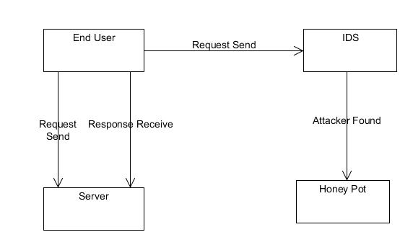

Client sends request to server and recives response. All requests sent to server are monitored by IDS and honeypot system. If the client is a attacker, his request will be blocked.

Level 1
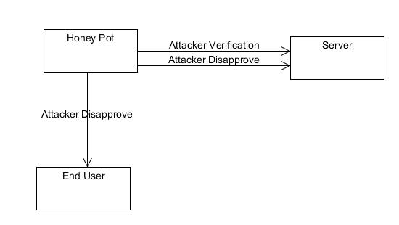
Level 2
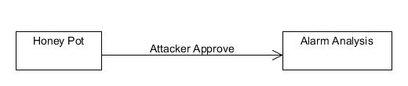
UML DIAGRAM
Use case diagram
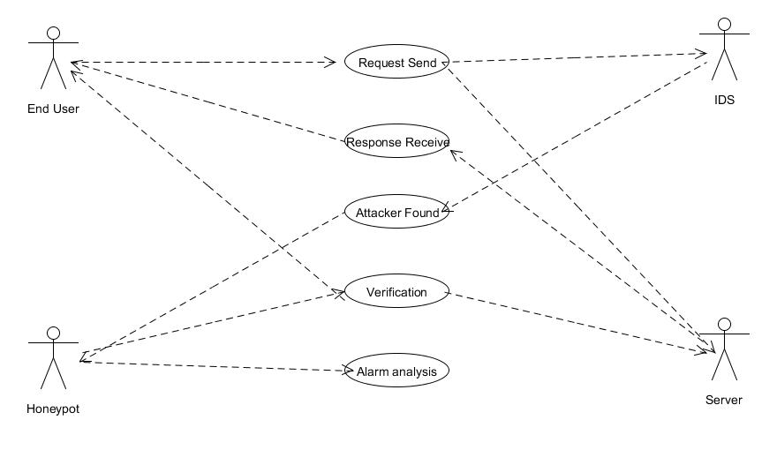

SEQUENCE DIAGRAM
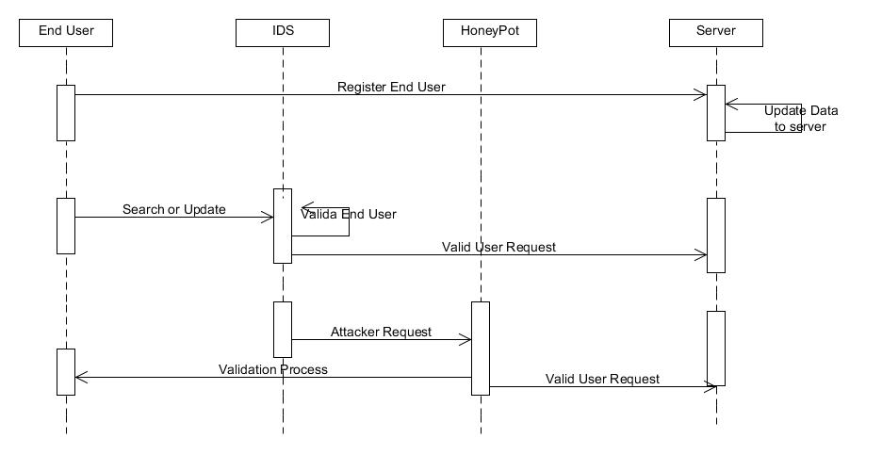
ACTIVITY DIAGRAM
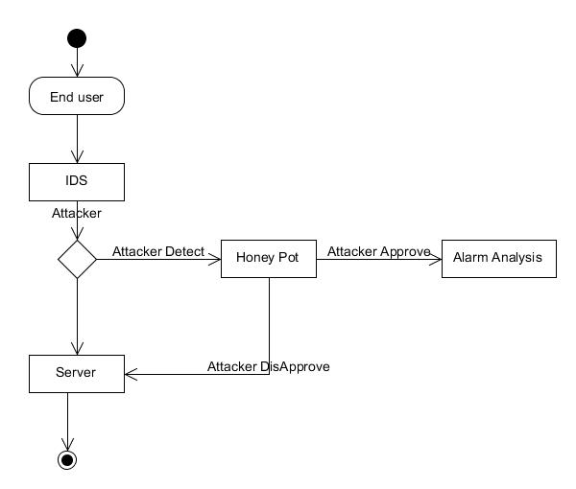
Result:
The IDS implemented in our project will monitor all the requests given to server from client. If the client is a attacker which is blocked by honeypot, requests will be denied. If client is a legitimate user, requests will be forwarded to server through IDS.
The blocked user can validate himself through secret code sent to him through mail from honeypot and again continue with his work incase he is blocked.

